AI-Based Crop Disease Diagnosis and Treatment Recommendation Using Production-System Knowledge and A* Heuristic Search
[sharukesh D]  Department of Computer Science and Engineering  Rajalakshmi Engineering College | [sadhok S]  Department of Computer Science and Engineering  Rajalakshmi Engineering College

Abstract—Farmers often identify crop diseases late because expert advice is scarce, and learned image classifiers need large labelled datasets that are not always available. This paper presents a lightweight, explainable crop-disease diagnosis system that uses no machine learning. Disease knowledge is held as IF-THEN production rules, and diagnosis is cast as an A* search in which each candidate disease is scored with f(n) = g(n) + h(n); the heuristic counts the symptoms on which a disease profile and the reported symptoms disagree. The system returns a ranked list with a confidence value, a severity label, treatment, and prevention advice. A Python reference implementation prints the full search trace, and a browser application with account login presents the results. The knowledge base covers 8 crops, 18 disease profiles and 11 symptoms. In consistency tests, A* ranked the intended disease first for 18 of 18 full profiles and for 32 of 33 inputs with one symptom omitted, against 29 of 33 for a breadth-first baseline, at a median of 8.1 µs per query. Because the test inputs are derived from the knowledge base, these results measure internal consistency rather than field accuracy. We discuss this and other limitations, including a knowledge base that has not been validated by a plant pathologist.
Index Terms—crop disease diagnosis, production systems, A* search, heuristic search, explainable AI, decision support, agriculture.
I. Introduction
Crop diseases reduce yield and quality, and the cost of a late or wrong diagnosis is paid in lost harvest and unnecessary spraying. Many diseases begin with similar visible signs: yellowing leaves, brown spots or wilting can each point to several causes [1]. A farmer without ready access to an agronomist may notice that something is wrong but not which disease is most likely, and therefore not which treatment to apply.
Deep convolutional networks trained on leaf images have reported high accuracy on curated image collections [2]–[4]. They need large labelled datasets, training compute and a clear photograph, and their reasoning is hard to show to the person who must act on the result. Rudin argues that for high-stakes decisions interpretable models should be preferred to explanations of black boxes [5]. We therefore use classical symbolic AI in the sense of Russell and Norvig [6]: a knowledge base of production rules [7], [8] and a deterministic search procedure.
Three difficulties shape the design. First, diseases share symptoms, so returning the first disease that matches a symptom is not enough. Second, the observed symptoms are often incomplete. Third, the user needs a ranked answer with reasons and advice, not only a label. This paper presents a crop-disease diagnosis system built around these needs. Its contributions are:
- Production-system knowledge base. IF-THEN rules for 18 diseases of 8 crops, each with a symptom profile, a severity label, treatment steps and prevention steps.
- A* ranking formulation. A state-space formulation in which a symptom-mismatch heuristic scores every candidate disease, giving a ranked list with a confidence value.
- Explainable output. A search trace of g, h and f for every candidate, and ranked alternatives with a comparison against an uninformed baseline.
- Prototype and honest evaluation. A Python implementation and a browser application with login, evaluated against a breadth-first baseline, together with a discussion of what the evaluation does and does not show.
Section II reviews related work, Section III formulates the problem, Section IV describes the system, Section V gives the implementation and experimental setup, Section VI reports results and limitations, and Section VII concludes.
II. Related Work
A. Learned plant-disease detection
Mohanty et al. trained deep networks on a large public collection of labelled leaf images and reported high accuracy on held-out images from the same collection, but markedly lower accuracy on images taken under other conditions [2]. Hughes and Salathé describe the open image repository that made such work possible [3], and Ferentinos reports further deep-learning results on a large image database [4]. These systems need labelled data and training, and output a class label rather than a treatment rationale.
B. Expert systems and production rules
A production system combines condition–action rules, a working memory and a control strategy [7]. MYCIN, which recommended therapy from clinical findings, is the classic rule-based diagnostic system [8], [9], and textbooks cover knowledge-base and inference-engine design [10]. Such systems are auditable by construction, but they are only as good as the rules written into them.
C. Heuristic search
Hart, Nilsson and Raphael introduced A*, which orders node expansion by f(n) = g(n) + h(n) [11]. Under an admissible and consistent heuristic over a defined cost model it returns a minimum-cost solution; the theory is covered in [6], [12]. Breadth-first search is uninformed and expands nodes level by level. We use A* as an informed ranking mechanism and breadth-first search as the baseline.
D. Explainability
Rudin cautions that post-hoc explanations of black-box models can be misleading and recommends inherently interpretable models for high-stakes use [5]; surveys of explanation methods are given in [13]. An itemised, rule-level trace supports this kind of transparency, although we make no claim of regulatory compliance.
E. Positioning
Table I positions this work. Learned models offer accuracy on image data but weak native explanations; classical expert systems offer transparency but are not usually applied to ranked, symptom-based crop diagnosis with treatment and prevention advice.
TABLE I
Comparison with related work
Work | Focus | Technique | Learned
[2] | Leaf-image disease detection | Deep convolutional network | Yes
[4] | Plant disease diagnosis from images | Deep convolutional network | Yes
[8], [9] | Medical consultation | Production rules | No
[5] | High-stakes decisions | Interpretable models preferred | Argues against black boxes
Ours | Symptom-based crop diagnosis | Rules + A* ranking + advice | No

III. Problem Formulation
A. Inputs and outputs
Let Σ be the set of 11 symptoms known to the system, and C the set of crops. For a crop c, let D(c) be its set of diseases, and for each d in D(c) let P(d) ⊆ Σ be its symptom profile. The input is a crop c and a set of reported symptoms S ⊆ Σ, with S ≠ ∅. The output is an ordering of D(c) from best to worst fit, a confidence value for each disease, and the severity, treatment and prevention advice of the best-fitting disease.
B. State space
The initial state is a root node holding (c, S). The successor function generates one candidate node n(d) for every d in D(c). The path cost g(n) is the number of steps from the root, which is 1 for every candidate. The best match is the candidate with the lowest evaluation value.
C. Heuristic and evaluation function
For a candidate disease d, the heuristic is the number of symptoms on which the profile and the report disagree:
h(d) = |P(d) Δ S| = |P(d) − S| + |S − P(d)| (1)
The first term counts symptoms the disease normally shows that were not reported; the second counts reported symptoms the disease does not explain. The evaluation function is
f(n) = g(n) + h(n), g(n) = 1 (2)
Candidates are ordered by increasing f(n); ties are broken by the order of the knowledge base, which makes the output deterministic. The value h(d) = 0 means the profile equals the report.
D. Confidence and baseline
For presentation, the system also reports the share of a disease’s own profile that was reported:
conf(d) = |P(d) ∩ S| / |P(d)| × 100% (3)
The ranking is determined by f(n); confidence is a display aid. The baseline is a breadth-first procedure that scans D(c) in knowledge-base order and returns the first disease with P(d) ∩ S ≠ ∅.
E. Evaluation measures
We report top-1 agreement (the intended disease ranks first), the number of ties at the top rank, agreement of the baseline on the same inputs, and query latency.
IV. Proposed System
A. Architecture
The system has four layers (Fig. 1). The presentation layer is a single-page application in HTML, CSS and JavaScript with account login, crop cards grouped into vegetables and grains, symptom chips with a live filter, and a Run button. The knowledge base holds the production rules. The inference engine computes h(n) and f(n) and orders the candidates. The recommendation module formats the result. There is no server and no database.
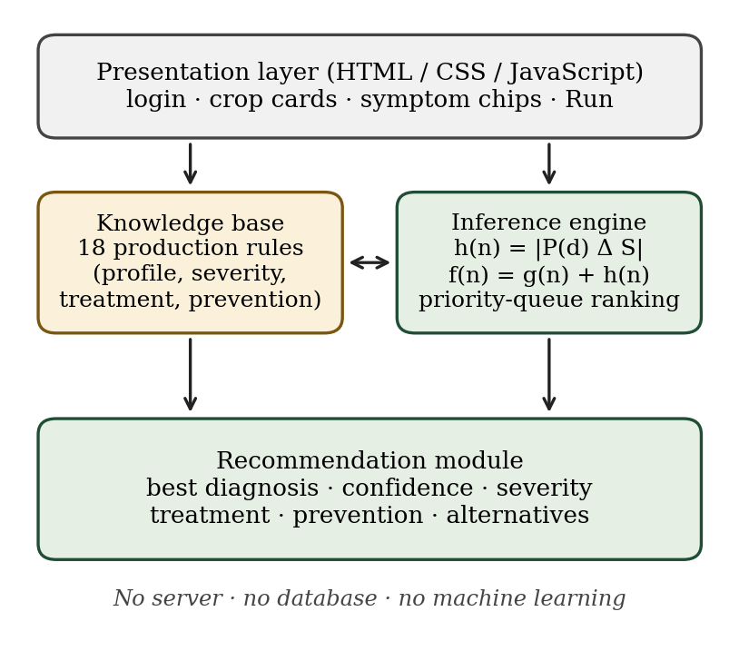
Fig. 1. System architecture.
B. Knowledge base
Each disease is one production rule: IF the crop is c AND the reported symptoms resemble P(d) THEN d is a candidate with the stored severity, treatment and prevention. The 18 rules are summarised in Table II. Knowledge lives in data, not in program logic, so a rule can be added or corrected without changing the search code.
TABLE II
Knowledge base: diseases per crop (|P|; severity)
Crop | Diseases
Tomato | Early Blight (3; medium), Leaf Spot (2; low), Late Blight (3; high)
Potato | Late Blight (3; high), Early Blight (3; medium), Black Scurf (2; low)
Chili | Anthracnose (3; high), Powdery Mildew (2; low)
Brinjal | Fruit Rot (3; high), Bacterial Wilt (2; medium)
Onion | Purple Blotch (3; medium), Downy Mildew (2; medium)
Cabbage | Black Rot (3; high), Clubroot (2; medium)
Wheat | Rust (3; high), Powdery Mildew (2; low)
Rice | Blast (3; high), Bacterial Leaf Blight (3; medium)

C. Inference engine
The engine generates one node per disease of the selected crop, scores it, and removes nodes from a priority queue in order of f(n) (Algorithm 1). Its cost per query is O(km + k log k) for k candidate diseases and m symptoms; here k ≤ 3 and m ≤ 11.
Algorithm 1. A* ranking for diagnosis
1: function DIAGNOSE(c, S)
2: if S = ∅ then return REQUEST-INPUT
3: frontier ← empty priority queue
4: for each d in D(c), in stored order do
5: g ← 1; h ← |P(d) Δ S|; f ← g + h
6: push (f, index, d) onto frontier
7: ranked ← empty list
8: while frontier is not empty do
9: append the node with smallest (f, index)
10: return ranked // ranked[1] is the best match

D. Recommendation and explanation
The Python implementation prints a trace such as “EXPAND ‘Leaf Spot’: g=1, h=1, f=2” for every candidate, followed by the ranked list with confidence. The browser application shows the best diagnosis with a severity badge and confidence bar, then the treatment steps, the prevention steps, the other possible matches with their f(n), and a one-line statement of what the baseline would have returned. Fig. 2 plots f(n) for a Tomato input {yellow leaves, brown spots, dark edges}: Early Blight has h = 0 (f = 1), Leaf Spot lacks one symptom (f = 2), and Late Blight shares one symptom and disagrees on four (f = 5).
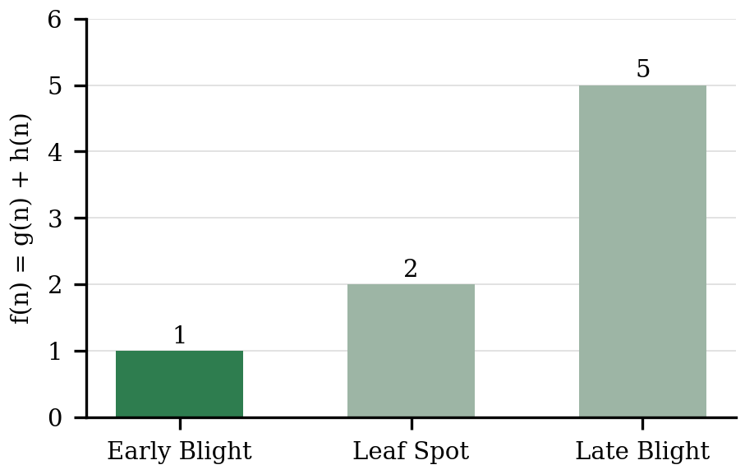
Fig. 2. f(n) for the Tomato example (lower is better).
E. Properties and caveats
Because every candidate is generated directly from the root, g(n) is the same for all of them and the order depends only on h(n). In this flat formulation A* therefore behaves as an informed best-first ranking, and greedy best-first search would give the same order. We use A* because the formulation extends to multi-step diagnosis, for example an agent that asks follow-up questions, where paths have different costs. The optimality guarantee of A* [11] is not claimed for this ranking. The confidence value in (3) can also reach 100% for a disease that ranks second: a profile that is a proper subset of the report is fully “covered” although the report contains a symptom it cannot explain.
V. Implementation and Experimental Setup
The reference implementation is a Python 3 program using the standard-library heapq priority queue; it prints the trace, the ranked results and the baseline answer. The browser application uses plain HTML, CSS and JavaScript with no framework. Sign-in is a demonstration feature: accounts are stored in the browser’s local storage with salted SHA-256 password hashes, the session is held in the browser, and there is no server, so it is not secure authentication.
Three input sets were generated from the knowledge base. S1: the full symptom set of each of the 18 diseases (18 inputs). S2: each symptom removed in turn from each of the 11 diseases that have three symptoms (33 inputs). S3: six hand-chosen inputs in which symptoms are shared between diseases. Counts over S1 and S2 were computed on the browser application’s 18-rule knowledge base with the same heuristic and baseline; S3 and timing used the Python implementation. Timing is the median of 20 repetitions of 1,000 queries on a three-candidate crop (Tomato), in Python 3 on a Linux container; absolute values depend on hardware. An end-to-end browser check of sign-in, diagnosis and sign-out completed without errors.
VI. Results and Discussion
A. Agreement with the intended disease
A* ranked the intended disease first for all 18 full profiles (Table III). With one symptom omitted it did so for 32 of 33 inputs (97.0%), while the baseline did so for 29 of 33 (87.9%). No input produced a tie for the top rank.
TABLE III
Agreement with the intended disease
Test set | Inputs | A* correct | Baseline correct | Top ties
S1: full profile | 18 | 18 (100%) | not measured | 0
S2: one symptom missing | 33 | 32 (97.0%) | 29 (87.9%) | 0

The single miss in S2 is Tomato Early Blight with dark edges omitted. The remaining symptoms, yellow leaves and brown spots, are exactly the profile of Leaf Spot, so Leaf Spot has h = 0 and Early Blight h = 1. Under the stored profiles Leaf Spot is the correct answer to the information given; the two diseases cannot be separated without asking about dark edges. Early Blight is still listed second.
B. Ambiguous inputs
Table IV shows S3. The baseline answers with the first stored disease that shares any symptom, so its answer depends on storage order: for {yellow leaves, brown spots} it returns Early Blight although the exact match is Leaf Spot, and for {dark edges, wilting} it again returns Early Blight where Late Blight fits best. A* avoids both errors. For a single symptom (Wheat, yellow leaves) A* prefers the disease with the smaller profile, Powdery Mildew, because it has fewer unreported symptoms; this reflects the mismatch count and not a higher likelihood, so sparse inputs should be read as a short list of candidates. The Potato input shows deterministic tie-breaking: Late Blight and Early Blight both have f = 5.
TABLE IV
Behaviour on ambiguous inputs (S3)
Crop | Symptoms | A* ranking: disease (f) | Baseline
Tomato | yellow leaves, brown spots | Leaf Spot (1), Early Blight (2), Late Blight (6) | Early Blight
Tomato | yellow, brown, dark edges | Early Blight (1), Leaf Spot (2), Late Blight (5) | Early Blight
Tomato | dark edges, wilting | Late Blight (2), Early Blight (4), Leaf Spot (5) | Early Blight
Rice | brown spots, dark edges | Blast (2), Bacterial Leaf Blight (6) | Blast
Wheat | yellow leaves | Powdery Mildew (2), Rust (3) | Rust
Potato | stunted growth | Black Scurf (2), Late Blight (5), Early Blight (5) | Black Scurf

C. Latency
A query took a median of 8.1 µs (minimum 7.9 µs, maximum 15.4 µs) in the Python implementation, including construction of the trace strings. Computation time is therefore not a limiting factor for a catalogue of this size.
D. What the results show
The expected answers in S1 and S2 are derived from the same knowledge base the engine uses, so the results show that the ranking is consistent with its definition, tolerant of one missed symptom in these tests, and better than an uninformed baseline on the same inputs. They do not show diagnostic accuracy on real crops, which would need expert-labelled field cases.
E. Limitations
(1) The disease profiles, severity labels and recommendations were assembled from general agronomic knowledge, simplified to binary symptoms, and have not been reviewed by a plant pathologist. (2) The model has no symptom intensity, plant part, growth stage, weather or regional prevalence, and assumes a single dominant disease. (3) Each crop has two or three candidates, so the task is easier than diagnosis over a large catalogue. (4) Confidence can overstate a partial match, as noted in Section IV-E. (5) The login is client-side only. (6) Recommendations that name chemicals must be used according to product labels and local regulations, and uncertain diagnoses should be confirmed by an agricultural extension officer; the system is an academic prototype.
VII. Conclusion and Future Work
We presented an explainable, non-machine-learning crop-disease diagnosis system that stores knowledge as production rules and ranks candidate diseases with A* search using a symptom-mismatch heuristic. In consistency tests it ranked the intended disease first for 18 of 18 full profiles and 32 of 33 inputs with one symptom missing, against 29 of 33 for a breadth-first baseline, and it returned treatment and prevention advice with ranked alternatives. The evaluation measures internal consistency, and the knowledge base still needs expert validation before any field use.
Future work includes a questioning agent that asks for the most discriminating next symptom, which would give the path cost g(n) real meaning; constraint-based pruning of candidates; weighted symptoms and an overlap-ratio confidence |P(d) ∩ S| / |P(d) ∪ S|; environmental rules using humidity and temperature; review of the profiles by agricultural experts followed by a field study; server-side authentication with a database; and regional-language support.
References
[1] G. N. Agrios, Plant Pathology, 5th ed. Burlington, MA, USA: Elsevier Academic Press, 2005.
[2] S. P. Mohanty, D. P. Hughes, and M. Salathé, “Using deep learning for image-based plant disease detection,” Front. Plant Sci., vol. 7, Art. no. 1419, 2016.
[3] D. P. Hughes and M. Salathé, “An open access repository of images on plant health to enable the development of mobile disease diagnostics,” arXiv:1511.08060, 2015.
[4] K. P. Ferentinos, “Deep learning models for plant disease detection and diagnosis,” Comput. Electron. Agric., vol. 145, pp. 311–318, 2018.
[5] C. Rudin, “Stop explaining black box machine learning models for high stakes decisions and use interpretable models instead,” Nat. Mach. Intell., vol. 1, no. 5, pp. 206–215, 2019.
[6] S. Russell and P. Norvig, Artificial Intelligence: A Modern Approach, 4th ed. Hoboken, NJ, USA: Pearson, 2021.
[7] A. Newell and H. A. Simon, Human Problem Solving. Englewood Cliffs, NJ, USA: Prentice-Hall, 1972.
[8] E. H. Shortliffe, Computer-Based Medical Consultations: MYCIN. New York, NY, USA: Elsevier, 1976.
[9] B. G. Buchanan and E. H. Shortliffe, Rule-Based Expert Systems: The MYCIN Experiments of the Stanford Heuristic Programming Project. Reading, MA, USA: Addison-Wesley, 1984.
[10] J. C. Giarratano and G. Riley, Expert Systems: Principles and Programming, 4th ed. Boston, MA, USA: Thomson, 2005.
[11] P. E. Hart, N. J. Nilsson, and B. Raphael, “A formal basis for the heuristic determination of minimum cost paths,” IEEE Trans. Syst. Sci. Cybern., vol. 4, no. 2, pp. 100–107, 1968.
[12] J. Pearl, Heuristics: Intelligent Search Strategies for Computer Problem Solving. Reading, MA, USA: Addison-Wesley, 1984.
[13] R. Guidotti et al., “A survey of methods for explaining black box models,” ACM Comput. Surv., vol. 51, no. 5, pp. 1–42, 2018.

